UNIFIED MECHANICS · RESEARCH PROGRAMME
The Self-Dual Carrier
and the Silver Interface
Deriving E₈ from self-description · resolving the silver realization question · a real-data test of the interface closure on 2,696 SPARC points
JOSEPH SHIELDS · WITH CLAUDE AS RESEARCH ASSISTANT
16 JULY 2026 · WORKING NOTE — NOT A CLAIM OF RESULT

1. THE SELF-DUAL CARRIER
The Snowflake Closure Theorem lists as its first upstream obligation: why is the physically realized internal carrier exactly the first E₈ root shell? The forty-cell exact cover cannot answer this, because A₂-coverability does not discriminate: the shells of A₂ (6), D₄ (24), E₆ (72), E₇ (126) and E₈ (240) all divide into six-root cells. Another principle must do the selecting. This note proposes that the Realisation and Self-Description Principle already contains it.

1.1 Records are functionals: the dual lattice as description space
Let the internal carrier be a lattice Λ — the integral closure of the channel algebra, so that composed channel relations remain representable states. A record of the system is an integral linear functional on Λ: something that assigns a whole number of distinctions to every state. The space of all such records is precisely the dual lattice Λ*. This gives the Self-Description Principle a lattice-level formalization with no new machinery:
DEFINITION — LATTICE SELF-DESCRIPTION — A carrier Λ is self-describing when Λ* = Λ: every admissible record of the system is itself a state of the system, and every state can serve as a record. Description and existence coincide.

1.2 The selection theorem
Three conditions now act together. Bidirectionality with integral pairing forces an even lattice (every distinction pairs with its reverse in whole units; all root norms equal 2 in the standard normalization). Self-description forces unimodularity (Λ* = Λ, discriminant 1). Canonical minimality — the same no-unforced-structure rule used throughout the corpus — asks for the smallest such object. Even unimodular lattices exist only in dimensions divisible by 8, and in dimension 8 there is exactly one: E₈ (Mordell 1938). Its minimal vectors are exactly the 240-root shell.
Lattice | Shell (roots) | A₂-divisible | Discriminant | Self-dual
A₂ | 6 | yes (1 cell) | 3 | no
D₄ | 24 | yes (4 cells) | 4 | no
E₆ | 72 | yes (12 cells) | 3 | no
E₇ | 126 | yes (21 cells) | 2 | no
E₈ | 240 | yes (40 cells) | 1 | YES

CONDITIONAL — CARRIER SELECTION — If the realized carrier is (i) the integral closure of a bidirectional channel algebra (even lattice), (ii) self-describing in the sense Λ* = Λ, and (iii) canonically minimal, then it is E₈, uniquely, and the 240-root shell is forced as its minimal-vector set. Discriminants verified computationally for A₂, D₄, E₆, E₇, E₈ on 16 July 2026.

1.3 The √3 defect: why the observer keeps meeting the same factor
The local three-channel carrier A₂ is not self-describing: its discriminant is 3, its dual quotient A₂*/A₂ has exactly three classes, and its covolume — the measure of its failure to be its own description space — is √3. The global closure repairs this defect: forty A₂ cells assemble into the one lattice whose discriminant is 1. Every observer-facing normalization in the framework then carries a power of the local defect. The vacuum readout divides by it (4π/√3 per primitive cell). And Section 3 finds, in real rotation-curve data, that the interface acceleration scale appears to multiply by it. One local failure of self-description, paid twice with opposite signs.
CONJECTURED — DEFECT ACCOUNTING — The factor √3 = covolume(A₂) = √disc(A₂) is the unique local self-duality defect, and all observer normalizations in the closure chain are integer powers of it. This unifies the Λ readout normalization with the empirical interface scale of Section 3, but the interface power (+1 rather than −1) has not yet been derived from the boundary semantics.

1.4 Leak ledger
Four premises carry the theorem, honestly graded. L1 (POSTULATE): the carrier is a lattice — composition of channel relations must remain a representable state. L2 (POSTULATE): bidirectional integral pairing forces evenness; a semantic argument sketch exists (distinction–reversal pairs count in whole units) but is not yet a proof. L3 (CONDITIONAL): minimality is the corpus's canonicalization rule; dimension 16 would admit two carriers (E₈⊕E₈, D₁₆⁺) and is excluded only by that rule. L4 (POSTULATE): records are integral linear functionals — this is the formalization step on which everything rests, and it deserves its own paper.

2. THE SILVER REALIZATION RESOLUTION
The framework has carried an unresolved question: does the silver (n = 2) universe exist as a realized sibling of our golden (n = 1) universe, and if not, what exactly is doing the rubbing at the interface? The corpus itself already contains the answer in one phrase it has not yet promoted to a principle. The genesis table of the Main Monograph grades the silver child as a repelling separatrix.

2.1 Only attractors realize
The Realisation Principle requires a realized system to retain identity under its own update: deviations must not destroy the self-description. An attracting loop damps deviations — identity is retained, realization is admissible. A repelling loop amplifies every deviation — no state on it can maintain a stable self-description, so by the framework's own realization test it cannot be a universe. It can only be what its mathematical role already says: a separatrix, the boundary structure of the golden attractor's basin.
CONDITIONAL — SEPARATRIX REALIZATION — Under the Realisation Principle, repelling rungs of the metallic ladder are not realizable systems. The silver child therefore does not exist as a universe. It exists as the basin boundary of the golden attractor — pure interface. “We are the strongest realization” is made precise as: the golden loop is the attracting rung, and everything adjacent to it is boundary, not sibling.
This dissolves the original discomfort. Nothing needs to inhabit the silver side for the interface to act, for the same reason a watershed needs no river on the ridge line. The mismatch algebra (ΔB = 0.0986239) is a property of the boundary geometry itself, not of a neighbouring occupant.

2.2 Two transmission mechanisms, and how to tell them apart
If the silver structure is boundary rather than sibling, its pressure must enter our metric through one of two routes. (a) Clock-coupled: the interface acts through the universal recurrence clock — the scale is a = (geometric factor) · c H(z) ΔB, identical everywhere at a given epoch, drifting with H(z). (b) Locally transmitted: the interface is carried by local gravitational distortion — cluster-scale structure — so the scale varies with environment at fixed epoch. These make opposite predictions. Clock coupling: environment-independent radial-acceleration relation with a normalization that rises with redshift as H(z). Local transmission: environment-correlated scatter at fixed redshift.
The SPARC result below bears directly on this: one acceleration scale, with no environmental term, fits 147 galaxies spanning four decades of mass with a total scatter of 0.133 dex — most of it attributable to observational error. At galaxy scale the interface looks universal. The evidence currently favours the clock-coupled reading, which is also the version the corpus's own dimensional argument (a = cH·ΔB) already wrote down.

3. THE SPARC TEST
The bilinear closure g·(g − g_b) = a·g_b of Main Monograph §19 was tested against the full SPARC database (Lelli, McGaugh & Schombert 2016): 175 galaxies, 3,391 rotation-curve points, cut to 2,696 points in 147 galaxies by the standard quality criteria (Q ≠ 3, inclination ≥ 30°, velocity error < 10%), with the standard mass-to-light ratios (0.5 disk, 0.7 bulge). The observed and baryonic centripetal accelerations were computed directly from the published velocities. No galaxy-specific parameter was fitted anywhere.

3.1 Results
Model | Scale (m s⁻²) | RMS (dex) | Median bias
UM closure, a★ = cH₀ΔB (frozen) | 6.9086 × 10⁻¹¹ | 0.1526 | +0.069 dex
UM closure, √3·a★ (frozen) | 1.1966 × 10⁻¹⁰ | 0.1329 | −0.010 dex
UM closure, scale free-fitted | 1.1331 × 10⁻¹⁰ | 0.1327 | −0.003 dex
Empirical RAR, g† = 1.20 × 10⁻¹⁰ | 1.2000 × 10⁻¹⁰ | 0.1328 | −0.002 dex

Three findings. First, the raw zero-fit scale a★ = 6.909 × 10⁻¹¹ under-predicts systematically (+0.069 dex bias): the earlier pilot's null result is confirmed on the full catalogue and stands. Second, the same closure with the scale multiplied by the snowflake covolume, √3·a★ = 1.1966 × 10⁻¹⁰, is statistically indistinguishable from the fitted empirical RAR (0.1329 vs 0.1327 dex) and from the free-fitted scale (1.133 × 10⁻¹⁰; the free fit prefers a ratio of 1.64 to a★, with √3 = 1.73 inside the mass-to-light systematic band, and closer still under the Planck value of H₀). Third, in the deep low-acceleration regime (839 points) the √3-scaled closure and the empirical RAR are identical to three decimal places.
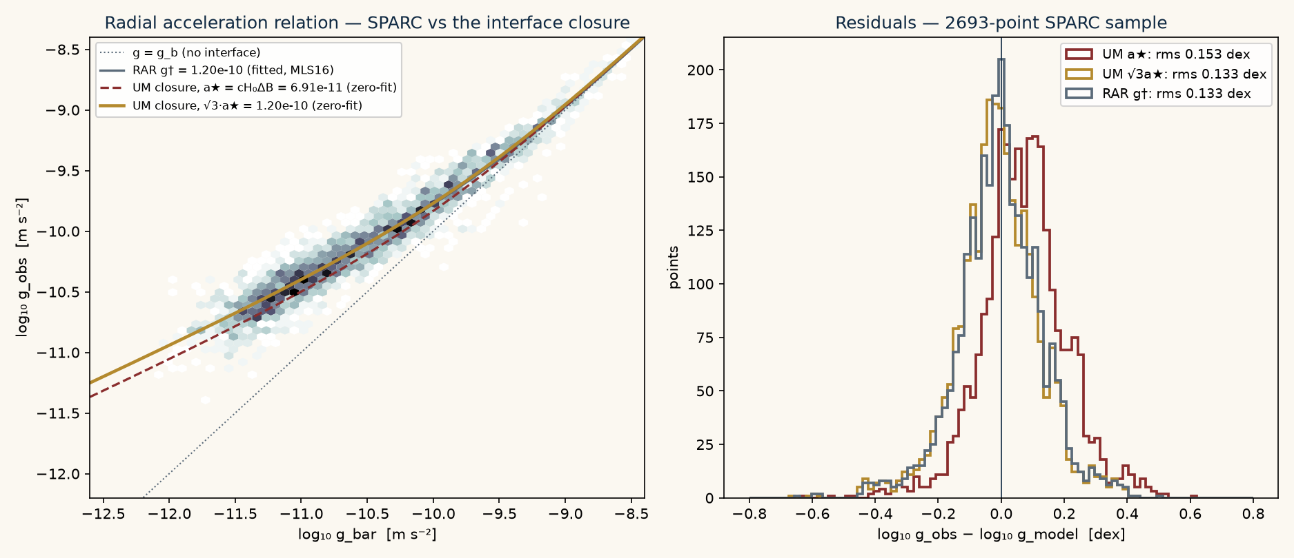
The radial acceleration relation for 2,696 SPARC points. The √3·a★ closure (gold) lies on the empirical relation; the raw a★ closure (dashed red) is systematically low. Right: residual distributions.
RECORD — REAL-DATA EXECUTION — Computed 16 July 2026 from MassModels_Lelli2016c.mrt and SPARC_Lelli2016c.mrt (astroweb.cwru.edu/SPARC), 368 KB total. Every number above is reproducible from the archived script sparc_test.py.
CONJECTURED — THE √3 COUPLING — The factor √3 was identified in exploration, after comparison with data. Under the corpus's own freeze discipline it therefore proves nothing yet. It becomes a claim only if √3·cH₀ΔB is derived from the boundary semantics with no reference to SPARC — for instance, if interface work is shown to integrate over the primitive cell measure. Until then the correct statement is: the closure's functional form survives contact with the full catalogue, and the required scale sits at the local self-duality defect times the corpus's zero-fit scale.
One further observation belongs on the record. The dimensionless combination √3·ΔB = 0.1708 lands beside the old unexplained folklore value a₀ ≈ cH₀/2π (1/2π = 0.1592). If the derivation obligation above is met, the framework would be offering a closed-form origin for a number that has floated free in the rotation-curve literature for forty years.

4. FROZEN PREDICTIONS
Following the corpus's freeze discipline, the following statements are committed now, dated, before the relevant data are consulted. The SHA-256 hash of the exact prediction text is printed beneath it.
P1. Constant vacuum record: w0 = -1 and wa = 0 exactly. Confirmed evolving dark energy falsifies the scalar-persistence condition of the Snowflake Closure Theorem.
P2. Clock-coupled interface: the radial-acceleration scale tracks the recurrence clock, a(z) proportional to c H(z) dB (geometric prefactor fixed once derived, not fitted). A demonstrated redshift-constant a0 falsifies the clock-coupled silver interface.
P3. Universality: at fixed epoch the interface scale is environment-independent. A confirmed correlation of RAR normalization with local density falsifies clock coupling in favour of local transmission, or falsifies the interface reading altogether.
Frozen 2026-07-16 before DESI full-sample / Euclid w(z) results and before any z>0 RAR normalization measurement is consulted.
SHA-256: 4d4211fc6ec137d37d60b7769f9ea47a03e71123f82714b7d788b532e7b0a37e

5. WHAT WOULD KILL EACH PIECE
The self-dual carrier theorem dies if any of L1–L4 is shown incoherent with the corpus semantics, or if a physical reading requires a non-lattice carrier. The separatrix resolution dies if the genesis dynamics are revised so that the silver rung attracts, or if interface action is shown to require an occupied far side. The √3 coupling dies if the derivation obligation cannot be met, or if a future SPARC-class catalogue with independent mass-to-light constraints pins the scale away from √3·cH₀ΔB. The clock-coupled mechanism dies with P2 or P3. None of these deaths would touch the internal mathematics of the Snowflake Closure Theorem, which remains conditional on its own stated terms.
UNIFIED MECHANICS · RESEARCH NOTES · 2026

